# 



## S:\ADM-MPA-OMC\SMC-Requests\SMC Resources\TEMPLATES\Report template_Aug17\New cover assets\17P-0961 Generic Report Template - Image 1.jpg

# Banksia Foundation Challenges



## Who We Are

*Banksia’s* ***Vision*** *– Banksia sees a world where sustainability is part of everyday life.*

*Banksia’s* ***Belief*** *– At Banksia we believe that we can do better than yesterday.*

*Banksia’s* ***Purpose*** *– Banksia exists to help improve and promote sustainability across Australia by recognising and promoting excellence, enabling innovation and building communities through the lens of the UN Sustainable Development Goals.*

The [Banksia Foundation](https://banksiafdn.com/) is a not-for-profit organisation that believes in the power of social and environmental impact through community engagement and sustainable business practices. Positive change inspires action: our prestigious annual awards highlight outstanding, innovative leadership across Australia.

**Our purpose**

We recognise past achievements that drive further innovations towards achieving a better future for everyone. We support and acknowledge emerging leaders in the social, sustainable, and environmental sectors across Australia.

Every year The Banksia Foundation discovers new possibilities, and it is our mission to recognise and acknowledge these. Our team work closely with award winners, judges, sponsors, and partners to educate and inform Australians about the positive effects of sustainable actions.

Banksia collaborates with government, business, and community to create awards, events, and programs that promote sustainable solutions.

Part of why Banksia exists is to show what is possible when individuals and organisations focus on positive environmental and social outcomes. As the world continues to evolve, global sustainability is non-negotiable.

We encourage a greater focus on innovation through the Banksia Ignite platform by engaging and uniting leaders across Australia to resolve specific sustainability issues relevant to their business.

No matter how big or small, everyone has an opportunity to create change and make an impact.

**Our History**

The Banksia Foundation was established in 1989 by a group of passionate people, recognising community members for their positive contributions to social and environmental sustainability initiatives. Today we receive national and international recognition as champions of sustainability across multiple industry sectors.

We have been conducting the Banksia Sustainability Awards for 33 years and are currently negotiating with the respective state governments to conduct the State Banksia Awards..

We pride ourselves on a highly relevant, strong and expanding brand. The Banksia Sustainability Awards are highly regarded for the diverse audience we attract, the integrity of our judging process and the key partnerships that we nurture, in order to ensure the ongoing legacy of the Awards and the associated programs.

We introduced the United Nations SDGs as the basis for the Banksia Awards in 2018. This has introduced the SDGs to a whole new audience, especially SMEs. As part of the Awards process we provide feedback to each entrant from the judges. Through these two elements we realised that the Awards’ process can become a valuable platform in providing even further informational feedback systems back to entrants.

## Challenge Summary

**Challenge 1: How could the Banksia Foundation provide their awardees with a report card on their leadership to advance the 17 UN SDGs?**

The Banksia Foundation recognises and rewards sustainability innovations and leadership and supports emerging leaders in the social, sustainable, and environmental sectors across Australia. The Foundation provides annual national and state awards in a broad variety of categories e.g. youth as changemakers, small and medium enterprises transformation. How could they create additional value for their awardees, in the form of a bespoke GRI or UN-aligned report card? How should this report card be designed, in order to demonstrate the awardee organisation’s innovations and leadership with regard to all or some of the 17 SDGs? You could consider reporting standards used around the world and the types of reports that will be most useful to awardees from a range of sectors.

*This challenge may be particularly exciting to students with an interest in Environment and Sustainability, Climate Science, Business, Project management, Marketing and comms, Design, Impact (environmental + social), Public Engagement* *and Computer Science/IT.*

**Challenge 2: How can Banksia Foundation help business leaders implement the SDGs as a conceptual framework within their organisation?**

The SDGs are a conceptual framework for creating momentum for change. They help people understand the multidimensional and interconnected impacts of failing to secure earth’s life support systems. Businesses can use the SDGs to think about and manage the different parts of their company. How could we help business leaders better understand the potential uses of the SDG framework for their businesses? You should consider outreach, engagement and adult education strategies as well as modalities/formats that suit these busy users. You may also consider how the SDGs can be used to transition different parts of the organization and the types of internal stakeholders that could use it.

*This challenge may be particularly exciting to students with an interest in Environment and Sustainability, Climate Science, Business, Project management, Marketing and comms, Design, Impact (environmental + social), and Computer Science/IT.*

## Relevant SDGs

This challenge links to most of the SDGs, but particularly focuses upon the highlighted ones.

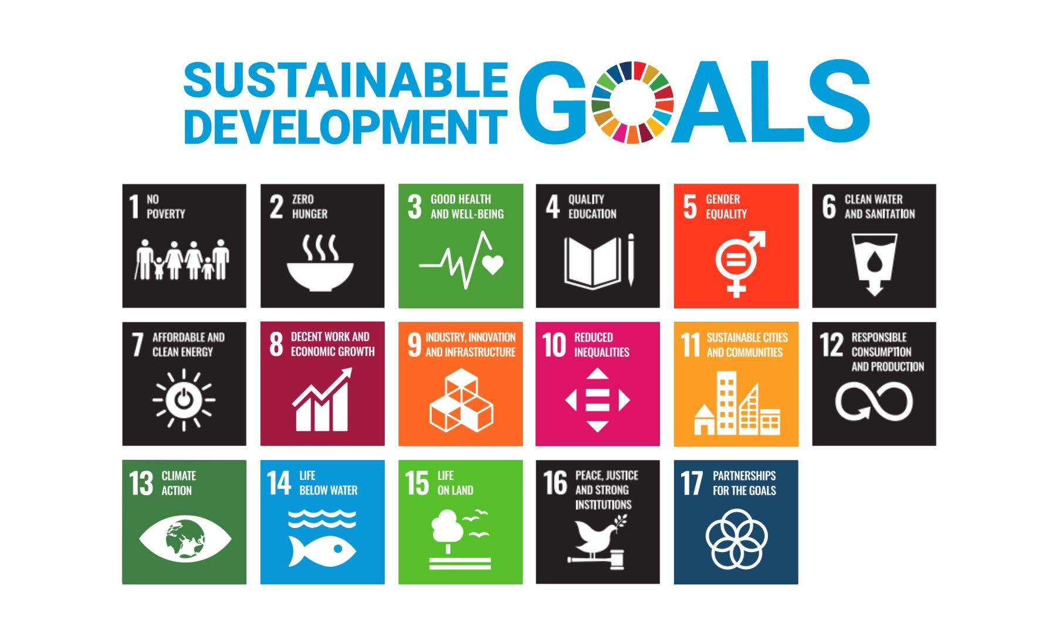

## Resources

<https://banksiafdn.com>

## Key representative/contact: Graz van Egmond, CEO\*

*\*Disclaimer: You will engage with your industry challenge holder via your coach and organised events. Please do not contact Dickie or his team directly.*